**UniGuide: An AI-Powered Virtual University Assistant for Instant Information Access**

*Abstract*— Most of the time, throughout the admissions process or for everyday necessities, students must visit universities or colleges to gather various information such as tuition costs, term schedules, etc. In addition to being labor-intensive and time-consuming, this procedure needs workers to give visitors the necessary information. Thus, a chatbot can be created to solve the issues. The project focuses on user-chatbot interaction that is accessible from any location at any time. With a few quick linguistic adjustments, the chatbot may be seamlessly integrated with any institution or college website. Chatbots offer a variety of information about colleges and universities as well as about students. Anyone who has access to the university's website can use the chatbot. The project uses the concept of Artificial Intelligence and Machine Learning. PHP Language is utilized for the development of Chatbot. User can ask university-related questions, then the query is applied as an input to algorithm, which processes the message and displays the corresponding response to the user. The Project GUI is similar to a Messaging Application.

1. **INTRODUCTION**

UniGuide is a cutting-edge artificial intelligence (AI) virtual assistant that aims to transform educational environments by facilitating information access. UniGuide strives to make it easier for instructors and students to find pertinent information by emphasizing immediate access and intuitive user interface. UniGuide is a cutting-edge artificial intelligence (AI) virtual assistant that aims to revolutionize education by giving users rapid access to a multitude of knowledge. UniGuide is a creative way to improve and expedite the academic experience for teachers, administrators, and students as the digital age continues to change higher education. Fundamentally, UniGuide uses cutting-edge artificial intelligence algorithms to provide quick and easy access to information.

For students, UniGuide becomes an indispensable companion throughout their educational voyage. With just a few clicks or voice commands, students can retrieve course materials, access real-time lecture notes, and receive personalized study recommendations tailored to their learning preferences. The virtual assistant empowers students to navigate complex academic requirements, providing clarity on degree programs, course prerequisites, and registration processes. Faculty members benefit from UniGuide's efficiency in managing administrative tasks, allowing them to focus more on teaching and research. The AI assistant assists in creating and organizing course content, facilitating communication with students, and offering insights into pedagogical best practices. Moreover, UniGuide acts as a collaborative platform, fostering communication and resource-sharing among faculty members across various departments.

**Your Personalized Gateway to Information**:

UniGuide learns your unique academic interests, schedule, and preferences. It acts as your personalized search engine, seamlessly integrating with your university's information systems to provide relevant and up-to-date information on:

Courses and curriculum: Explore course descriptions, syllabi, prerequisites, and instructor information. Stay updated on class schedules, assignments, and deadlines.

Grades and transcripts: Access your latest grades, track your academic progress, and analyze trends.

Registration and administrative tasks: Register for courses, update personal information, and handle administrative tasks with ease.

Campus resources and events: Discover libraries, labs, support services, student organizations, and upcoming campus events tailored to your interests.

Financial aid and scholarships: Stay informed about scholarships, grants, and financial aid options relevant to your profile.

1. **E**XISTING **SYSTEM**

The current information access system within universities relies on conventional methods such as manual searches, website navigation, and query-based systems. These methods, while functional, exhibit several limitations:

**Tedious Navigation**: Users often need to navigate through multiple webpages, portals, or databases to locate specific information, leading to a time-consuming and tedious process.

**Limited Personalization**: Existing systems may lack the ability to personalize information delivery based on individual user preferences and history, resulting in a one-size-fits-all approach.

**Inefficient Query Processing**: Traditional query-based systems might struggle with natural language understanding, making it challenging to comprehend user queries effectively and deliver precise results.

**Fragmented Information Sources**: University information is typically scattered across various platforms, including academic databases, course catalogs, and administrative portals. This fragmentation can hinder the cohesive retrieval of relevant data.

**User Experience Challenges**: The overall user experience may be suboptimal due to complex interfaces, slow response times, and a lack of adaptability to evolving user needs and technological advancements.

**Limited Integration**: Existing systems may face challenges when attempting to integrate with emerging technologies, hindering their adaptability and responsiveness to the rapidly changing landscape of information technology.

**Manual Search and Navigation**: Users typically rely on manual searches through university websites, online portals, and physical documents to access the information they need. Navigation through various pages and interfaces is often time-consuming and may require familiarity with different systems.

**Fragmented Information Sources**: University information is dispersed across multiple platforms, including academic databases, departmental websites, student portals, and administrative systems. This fragmentation leads to challenges in consolidating and presenting information cohesively.

**Keyword-Based Query Systems**: Existing systems often employ basic keyword-based query systems that may lack the sophistication to understand natural language effectively. Users might need to craft precise queries, and even then, the results may not always be accurate or contextually relevant.

1. **PROPOSED SYSTEM**

UniGuide proposes a novel approach to information access in universities by leveraging artificial intelligence, natural language processing, and advanced algorithms. This virtual assistant aims to overcome the shortcomings of the existing system by [outline the key features and functionalities of UniGuide. UniGuide envisions a revolutionary AI-powered virtual university assistant designed to overcome the limitations of the existing information access systems in academic environments. The proposed system incorporates advanced technologies and intelligent algorithms to create a seamless and efficient information retrieval experience for students and faculty.

1. **IMPLEMENTATION PROCESS**

Implementation is the stage in the project lifecycle where the design specifications are translated into actual code, databases are created, and the system starts to take shape. For UniGuide, an AIpowered virtual university assistant, implementation involves turning the detailed design into a functional and operational system.

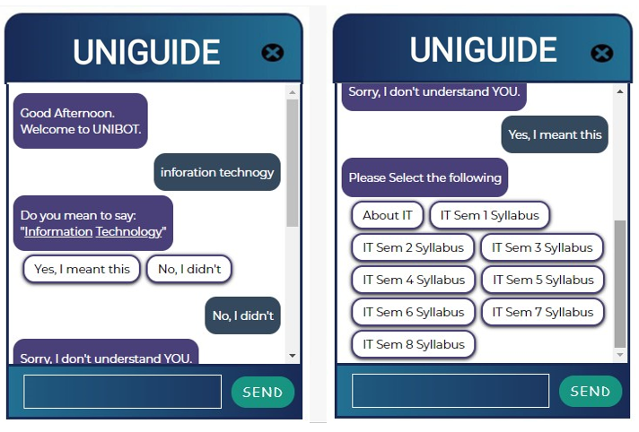

Implementation for UniGuide:

1. Coding and Development:

Programming Languages: Utilize programming languages such as Python, JavaScript, or others based on the chosen technology stack.

Version Control: Implement version control systems (e.g., Git) to track changes and facilitate collaboration among developers.

1. Database Implementation:

Create Database: Set up the database based on the defined schema from the database design phase. Implement tables, relationships, and constraints as outlined in the Entity-Relationship Diagram (ERD).

1. Module Implementation:

User Interface (UI) Module: Develop the user interface based on the UI design specifications.

Ensure responsive and user-friendly interactions. Natural Language Processing (NLP) Module:

Implement NLP algorithms and integrate them into the system.

# **Algorithm Implemented**

Pattern Matching **:**

Pattern matching involves identifying predefined patterns or keywords in user input to understand the user's intent. Regular expressions or simple keyword matching can be used for this purpose.

Machine Learning Models:

Decision Trees:For making decisions based on a set of rules.

Support Vector Machines (SVM):For classification tasks.

Naive Bayes:Particularly for text classification.

Recurrent Neural Networks (RNN): For handling sequential data, such as conversational context.

Reinforcement Learning :

Reinforcement learning can be used to allow chatbots to learn from user interactions and improve over time. The chatbot receives feedback in the form of rewards or penalties based on the quality of its responses.

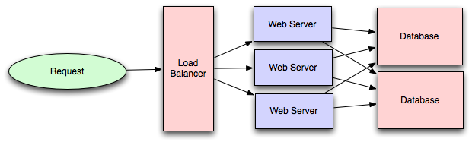

1. **CONCLUSION**

UniGuide has the potential to revolutionize the way students navigate university life, providing instant access to information and personalized recommendations tailored to their unique needs.

UniGuide has been designed with students in mind, providing an intuitive and user-friendly chat interface that makes it easy to get the information you need quickly and efficiently.

1. **FUTURE SCOPE**

UniGuide, an AI-powered virtual university assistant, revolutionizes information access for students. It offers instant and personalized support, guiding users through academic queries, course details, schedules, and campus resources. UniGuide employs advanced natural language processing to understand and respond to diverse inquiries, enhancing the overall learning experience. With its seamless integration into university systems, it streamlines administrative tasks and provides real-time updates. UniGuide aims to foster efficient communication between students and their academic environment, creating a dynamic and user-friendly platform that contributes to a more connected and informed university community. Its scope extends beyond traditional assistance, shaping a future where information is easily accessible and tailored to individual needs.

**Technical Scope:**

Programming Languages: UniGuide should be developed using modern and widely supported programming languages, ensuring compatibility with various platforms and environments.

Frameworks and Libraries: UniGuide should leverage appropriate frameworks and libraries for NLP, information retrieval, multimodal interaction, and UI development. Data Storage: UniGuide should utilize secure and scalable data storage solutions to handle large volumes of university information and user data.

1. **REFERENCES**
2. Neelkumar P. Patel; Devangi R. Parikh; Darshan A. Patel; Ronak R. Patel, “AI and Web-Based Human-LikeInteractive ssUniversity Chatbot (UNIBOT)”, 2020 3rd International conference on Electronics, Communication and Aerospace Technology (ICECA).
3. Drishti Malik Vibhor Sharma, Monika Goyal, “An intelligent behaviour shown by chatbot system”, International Journal of New Technology and Research, 2017.
4. Balbir Singh Bani, Ajay Pratap Singh, “College Enquiry Chatbot Using A.L.I.C.E”, International Journal of New Technology and Research 2017. [3] Nitesh Thakur, Akshay Hiwrale, Sourabh Selote, Abhijeet Shinde, Prof. Namrata Mahakalkar, “Artificially Intelligent Chatbot”, Department of Computer Science & Engineering, Priyadarshini Institute of Engineering & Technology, Nagpur.
5. M. Dahiya, “A tool of conversation: Chatbot”, Dept. of Computer Science, Maharaja Surajmal Institute, Janakpuri, India, 2017.
6. Tracy A. Tindall Michael G. Makar, “Dynamic chatbot”.
7. B. R. Ranoliya, N. Raghuwanshi and S. Singh, “Chatbot for University Related FAQs”, 2017 International Conference on Advances in Computing, Communications and Informatics (ICACCI), Udupi, 2017.
8. Amey Tiwari, Rahul Talekar, Prof.S.M.Patil, “College Information Chat Bot System”, International Journal of Engineering Research and General Science 2017.
9. Himanshu Agarwal, Rameshwari Deshmukh, Supriya Biradar, Bhagyashri Cheke, “Chat-Bot Real Virtual Human”, International Journal of Advanced Research in Computer and Communication Engineering 2018.
10. Anirudh Khanna, Bishwajeet Pandey, Kushagra Vashishta, Kartik Kalia, Bhale Pradeepkumar and Teerath Das, “A Study of Today’s A.I. through Chatbots and Rediscovery of Machine Intelligence”, International Journal of u- and e- Service, Science and Technology 2015.
11. Sarthak V. Doshi, Suprabha B. Pawar, Akshay G. Shelar, Shraddha S. Kulkarni, “Artificial Intelligence Chatbot in Android System using Open Source Program-O”, International Journal of Advanced Research in Computer and Communication Engineering, 2017.
12. Fernando A. Mikic Fonte, Mart´ın Llamas Nistal, Juan C. Burguillo Rial, Manuel Caeiro Rodr´ıguez, “NLAST: A natural language assistant for students”, Department of Telematics Engineering, University of Vigo, Vigo, Spain.
13. V.Manoj Kumar, A.Keerthana, M.Madhumi``tha, S.Valliammai, V.Vinithasri, “Sanative Chatbot For Health Seekers”, International Journal Of Engineering And Computer Science 2016.